**AD.1.Account creation**

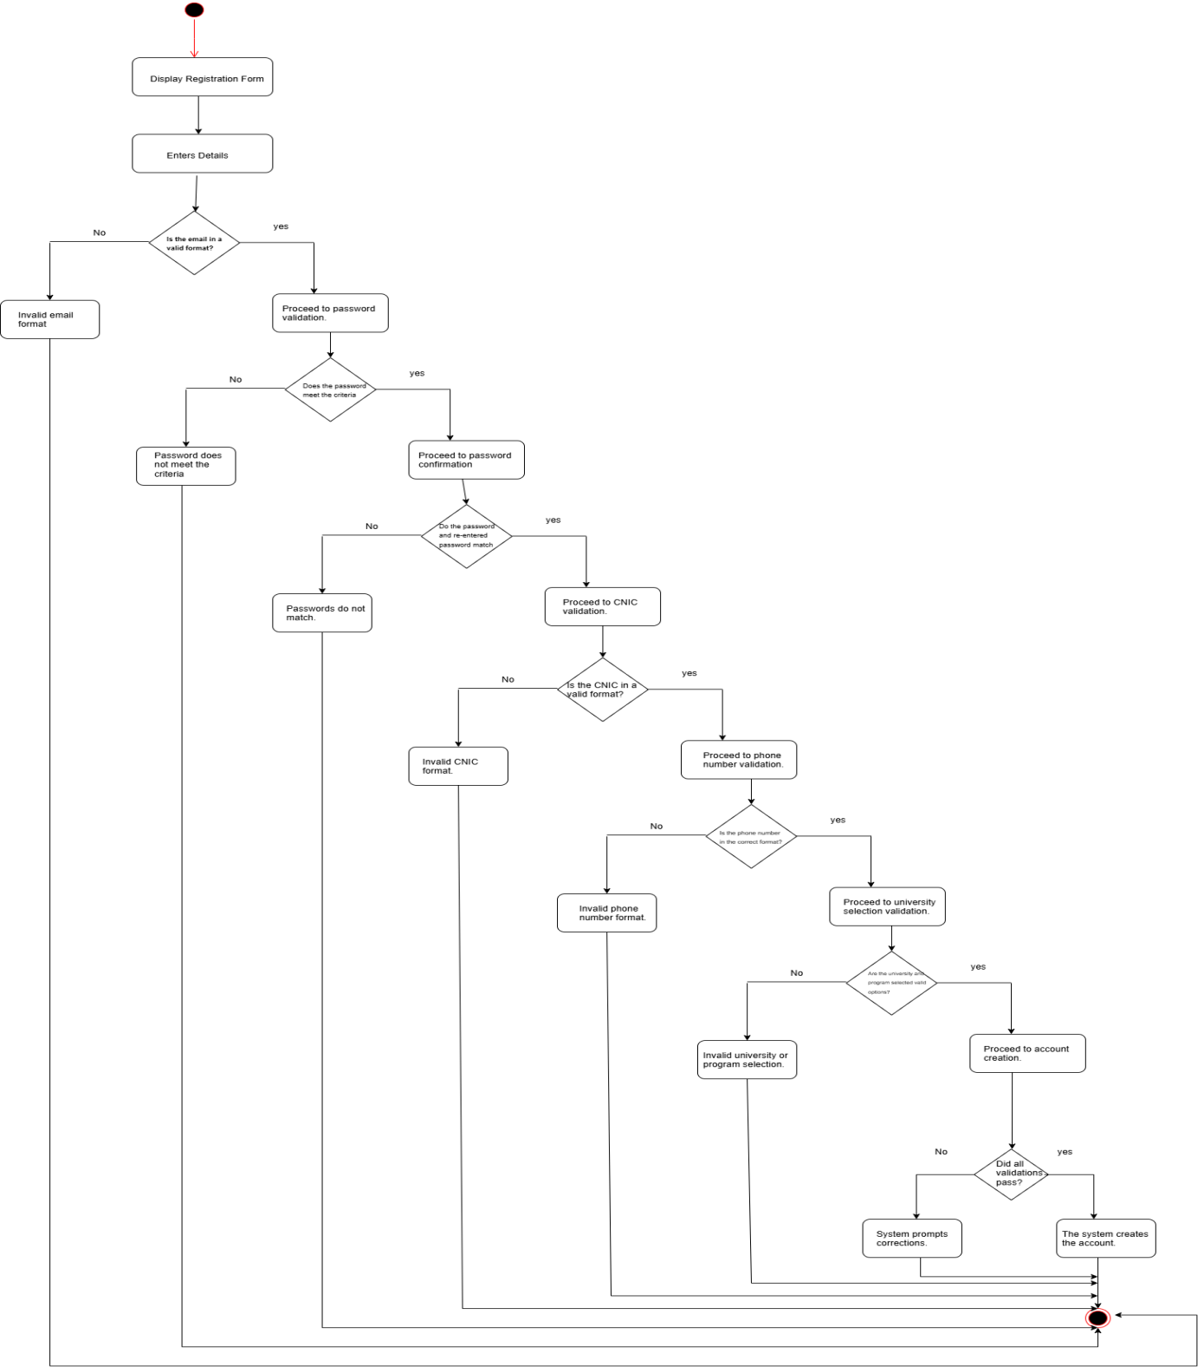

*Figure#1: Account Creation*

**AD.2.Manage profile**

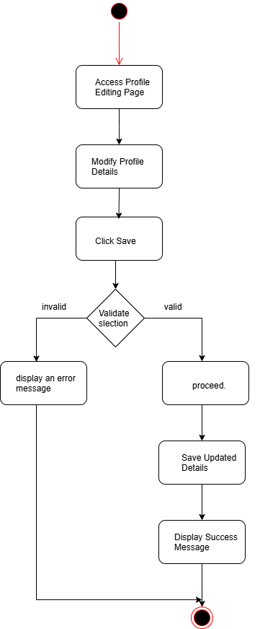

*Figure#2: Manage account*

**AD.3.Manage repository**

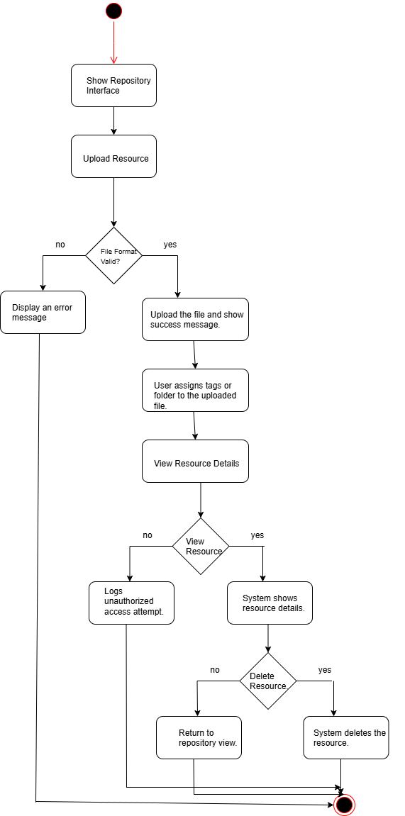

*Figure#3: Manage repository*

**AD.4.Through bank**

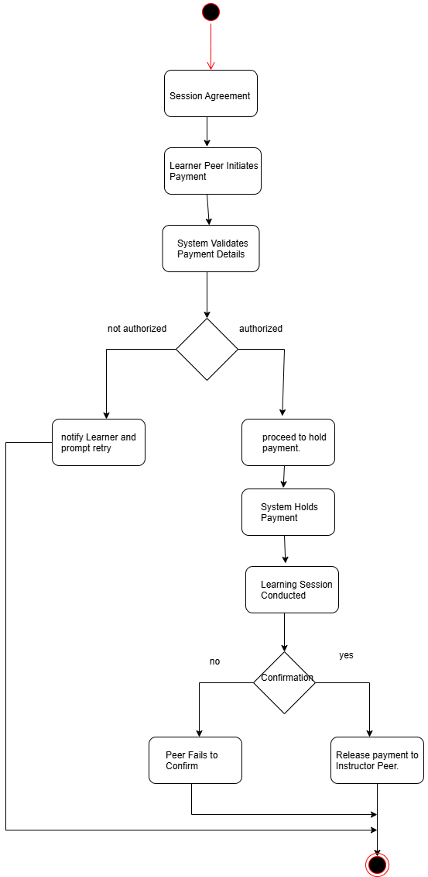

*Figure#4: Through bank*

**AD.5.Through food**

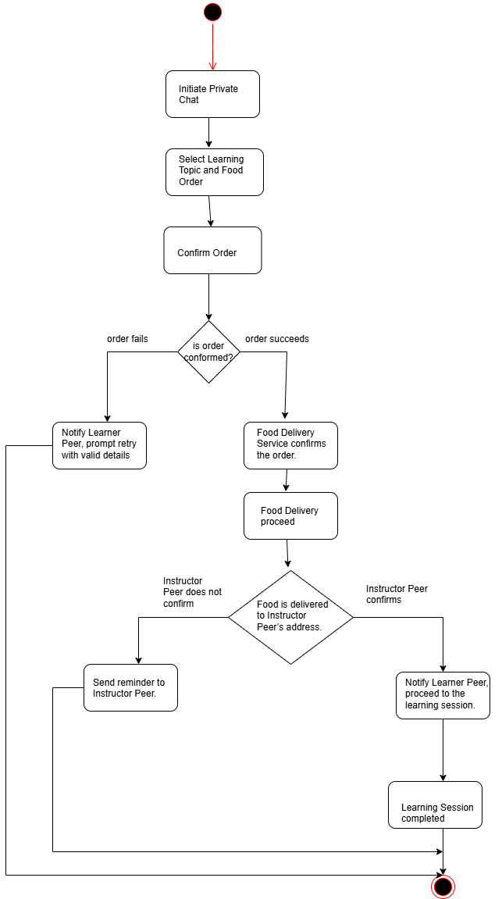

*Figure#5: Through food*

**AD.6.Broadcast session request**

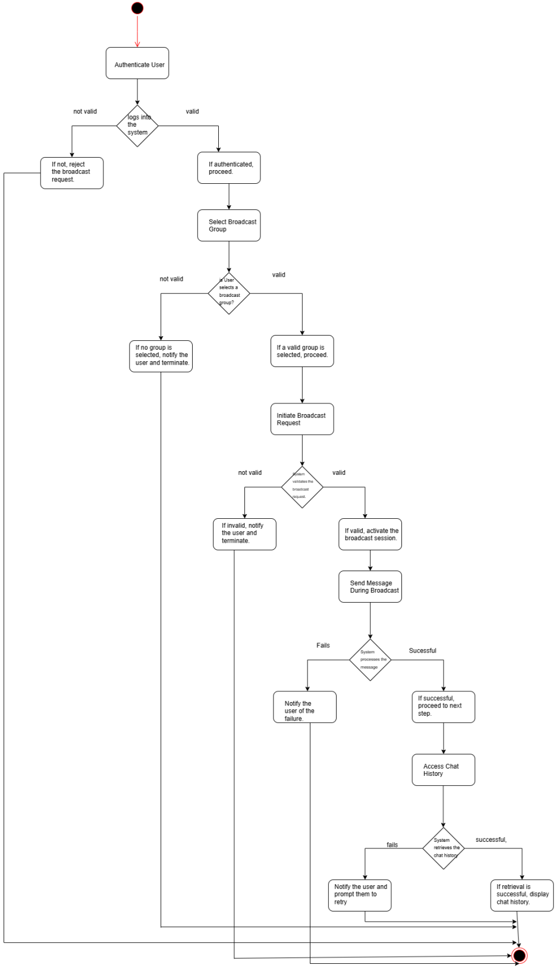

*Figure#6: Broadcast request session*

**AD.7.personal session request**

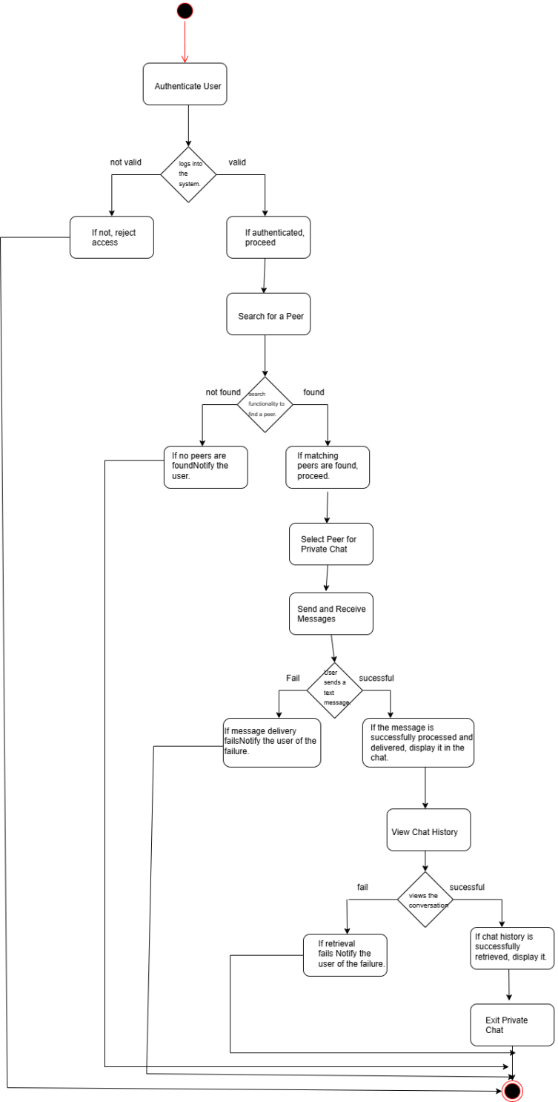

*Figure#7: personal request session*

**AD.8.Schedule study session**

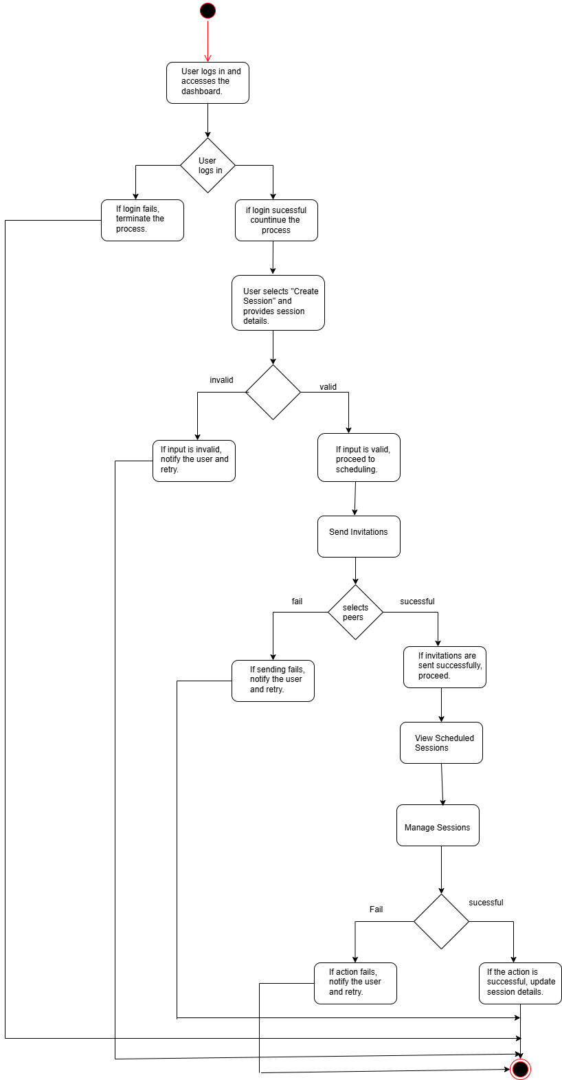

*Figure#8:Schedule study session*

**AD.9.Conduct study session**

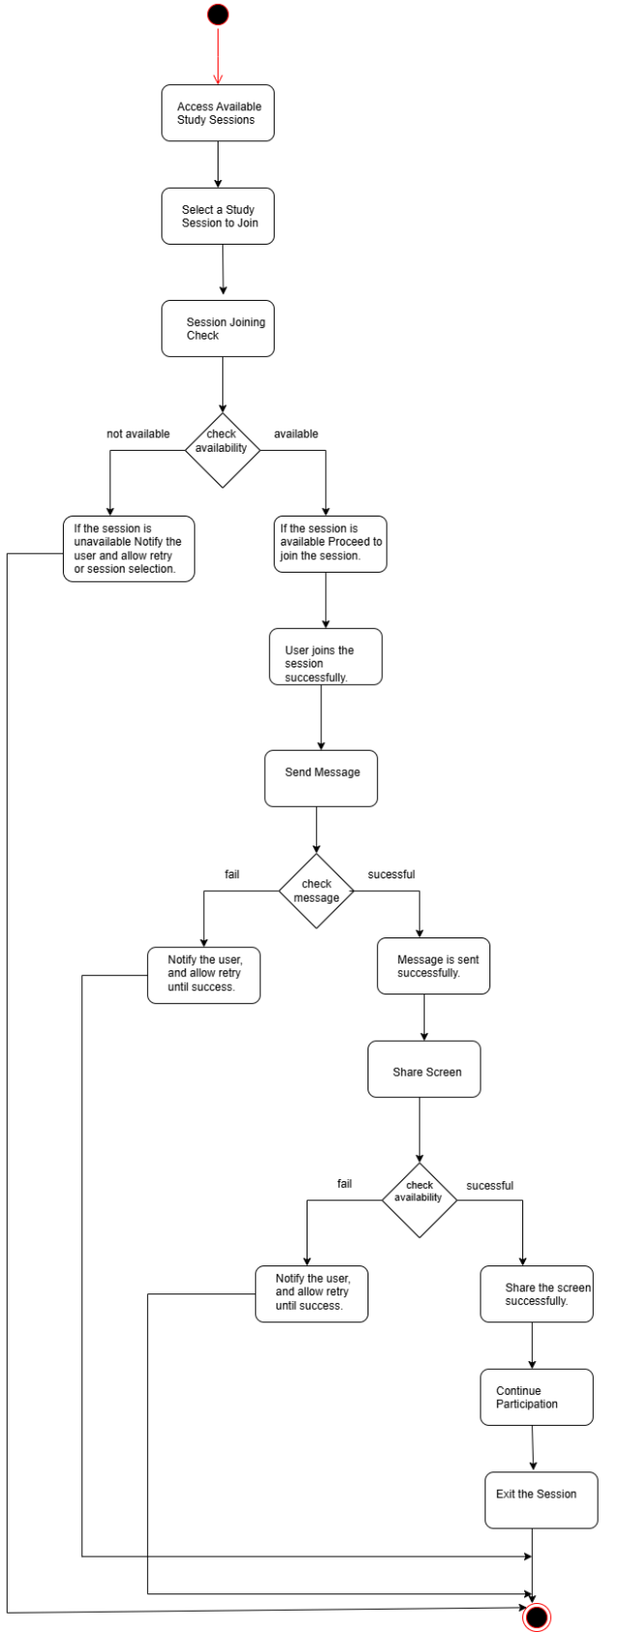

*Figure#9:Conduct study session*

**AD.10.Send Complaints**

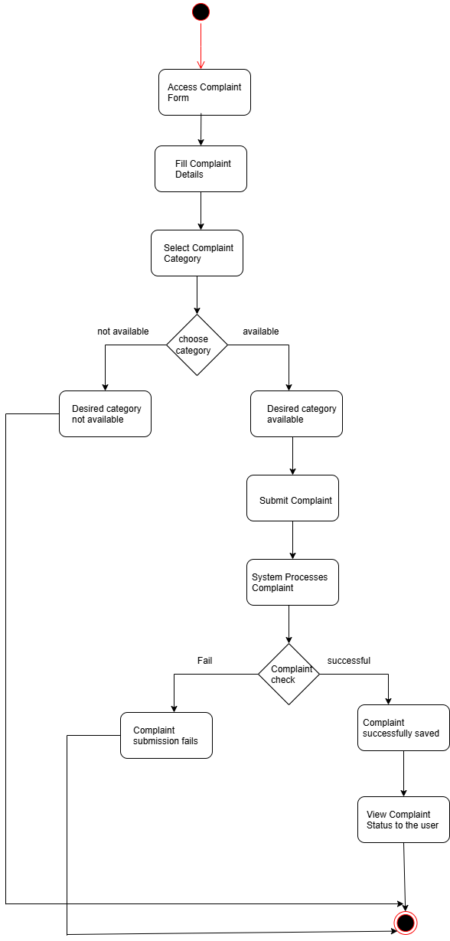

*Figure#10:Send complaints*

**AD.11.University admin Login**

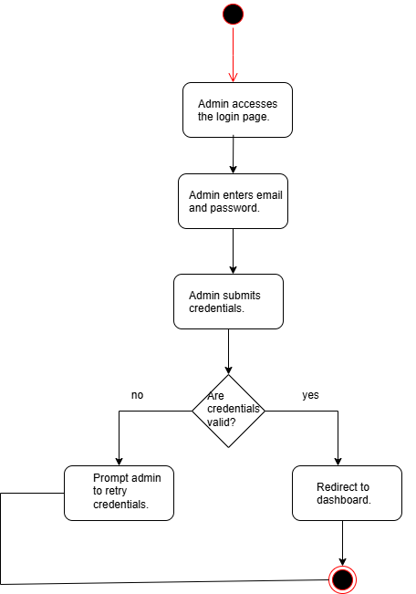

*Figure#11: University admin login*

**AD.12.Verify student accounts**

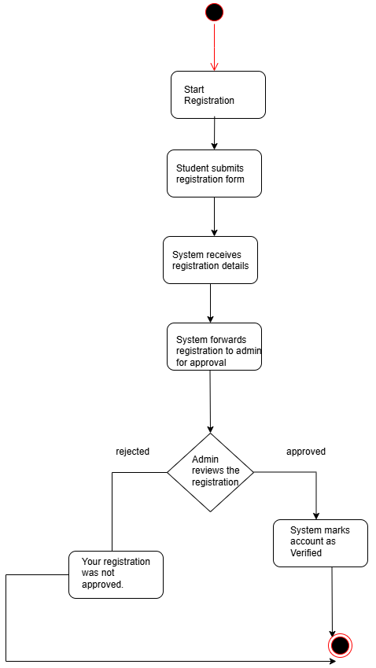

*Figure#12: Verify students account*

**AD.13.Manage profile**

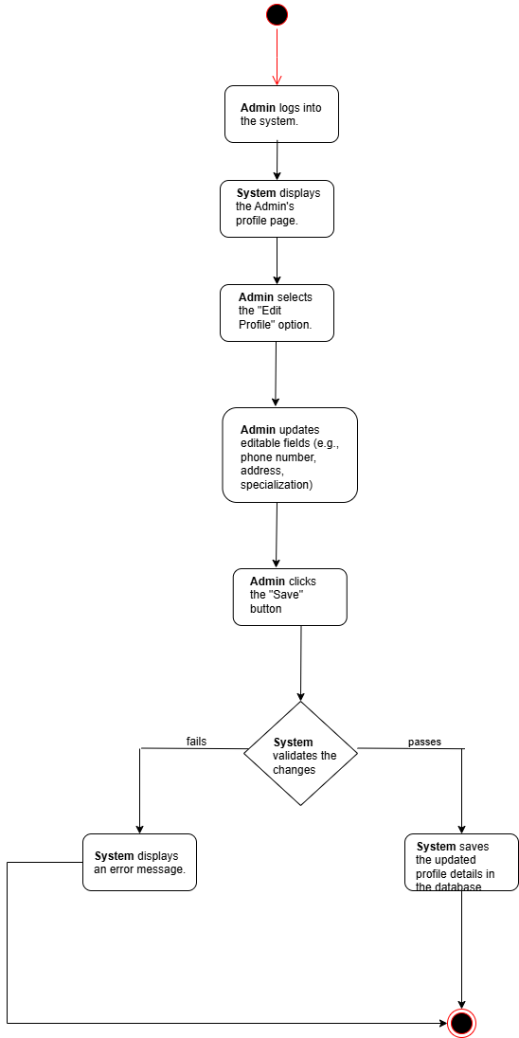

*Figure#13:Manage profile*

**AD.14.Manage student complaints**

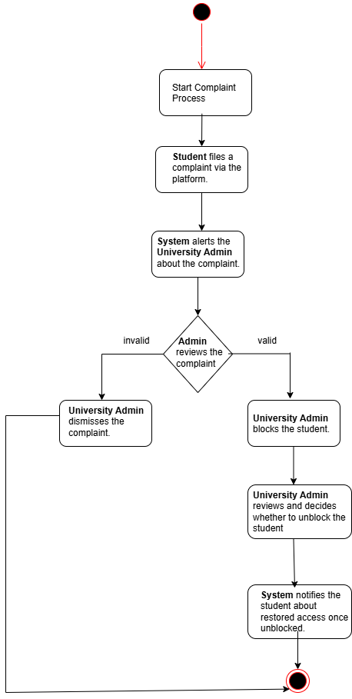

*Figure#14:Manage student complaints*

**AD.15.Superadminlogin**

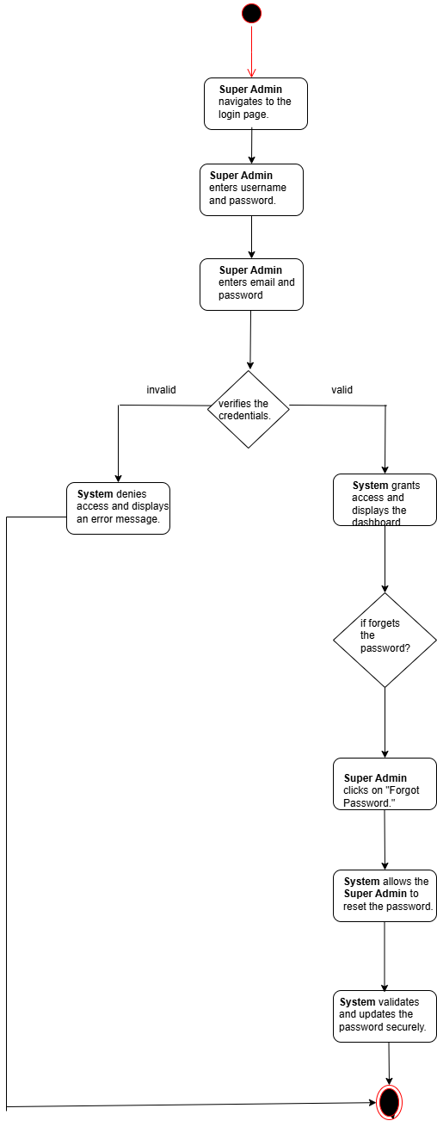

*Figure#15:Superadmin login*

**AD.16.Register university admins**

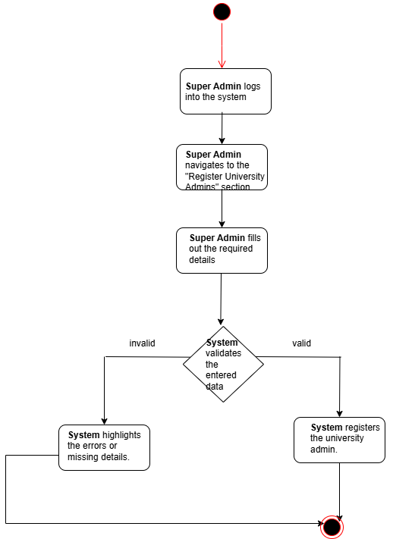

*Figure#16:Register university admins*

**AD.17.Manage universities and campuses**

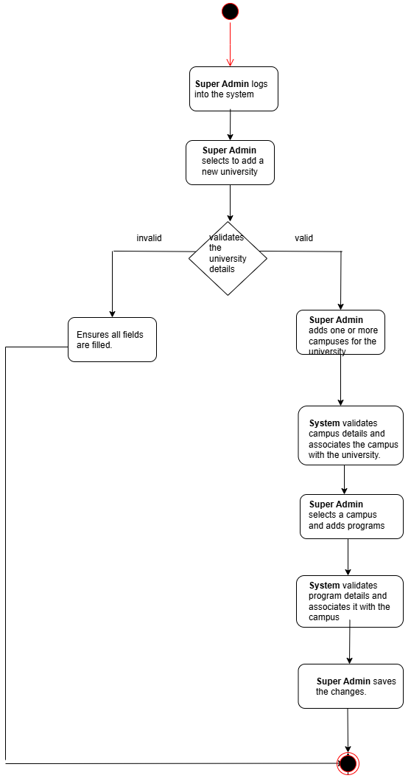

*Figure#17:Manage universities and campuses*